**Traverse City Little League Safety Plan**

**2023**

**Traverse City Little League**

  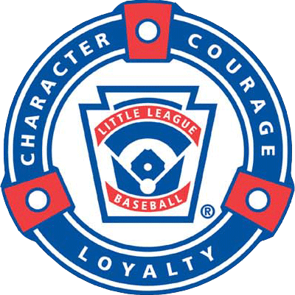



**Mandatory Coaches Meeting for League Rules, Practices, Equipment, and Safety & First Aid will be held at Kendall Electric, 2458 N Aero-Park Ct, Traverse City, MI Time and date to be determined and distributed to all coaches via email Safety Plans will be distributed at that time.**

**Safety Plans will be available in all concession areas and facilities sheds for reference.**

**Child Protection Program**

Traverse City Little League will conduct background checks on Managers, Coaches, Board of Directors, members and any other persons, volunteers or hired workers who provide regular service to the league and/or have a repetitive access to, or contact with, players or teams. Individuals are also required to complete and submit a Little League Volunteer Application to their local league. (Form is attached to this packet.) **A Traverse City Little League committee (Mike Richard, Jon Pickard, and Kyle Kendzicky) and ultimately the League President will handle all background checks.**

**2023 Season**

**Traverse City Little League**

**2023 Board of Directors**

|  |  |  |
| --- | --- | --- |
| Name | Email | Position |
| Mike Richard | [tcllpres@outlook.com](mailto:tcllpres@outlook.com)  mrstrikersupply@gmail.com | President / Coach Coordinator / Player Agent Seniors |
| Josh Francis | jfrancisproperties@gmail.com | Vice President / Fundraising/ Marketing  Player Agent |
| Jon Pickard | [jon@twopicks.com](mailto:mrstrikersupply@gmail.com) | Information Officer/ Registration Officer/Schedule Officer |
| Samantha Pomranky | Samanthapomranky@gmail.com | Secretary |
| Kyle Kenzicky | Kyle.kendzicky@gmail.com | Safety Officer |
|  |  |  |
| Phil Peterson | Phil.Peterson@kendallelectric.com | Player Agent Majors/ Juniors /All Star Coordinator |
| Lauren Jeffries  Matt Cozzens | [llbjeffries@yahoo.com](mailto:Kent.r.wood@gmail.com)  mattcozzens@gmail.com | Equipment Officer / Player Agent Coach Pitch / Minors |
|  |  |  |
| Eric Coles | Eric_coles83@yahoo.com | Treasurer |
|  |  |  |
| Raymond Beneway | raymondbenaway@gmail.com | Umpire Coordinator |
|  |  |  |
|  |  |  |
|  |  |  |

***Expectations***

What do I expect from my players?

* To be on time for all practices and games.
* To always do their best.
* To be cooperative at all times and share team duties.
* To be positive with teammates and coaches at all times.
* To not become upset at mistakes, their own or others, we all make them.
* To understand that winning and losing are both important parts of any sport.

What can you and your child expect from me?

* To be on time for all practices and games.
* To be as fair as possible in giving playing time to all players.
* To do my best to teach the fundamentals of the game.
* To be positive and respect each child as an individual.
* To set reasonable expectations for each child and the season.
* To teach the players the value of winning and losing.
* To be open to ideas and suggestions.
* To treat all players, umpires, and parents with respect.

What do I expect from parents and family?

* To come and enjoy the game, cheer and make all players feel important.
* To allow me to coach and run the team. Do not coach your child from the stand. It will only confuse him, and others.
* To try not to question my leadership. All players will make mistakes and so will I.
* To not yell at coaches, players, or most importantly UMPIRES. Be a positive role model for all players.
* To call me with any questions or concerns. Please do not confront me in front of players or other parents.

Finally, please remember that there will be players with very different skill levels on every team. Coaches strive to give all kids equal play time. We also try very hard to balance skill levels of the players with safety issues of the game. They are all out there to learn and HAVE FUN!! Let’s make this a fun and positive experience for all of our kids!!

**LET’S ALL HAVE A FUN AND SAFE**

***2023 SEASON***

**THINK SAFE - PLAY SAFE – BE SAFE**

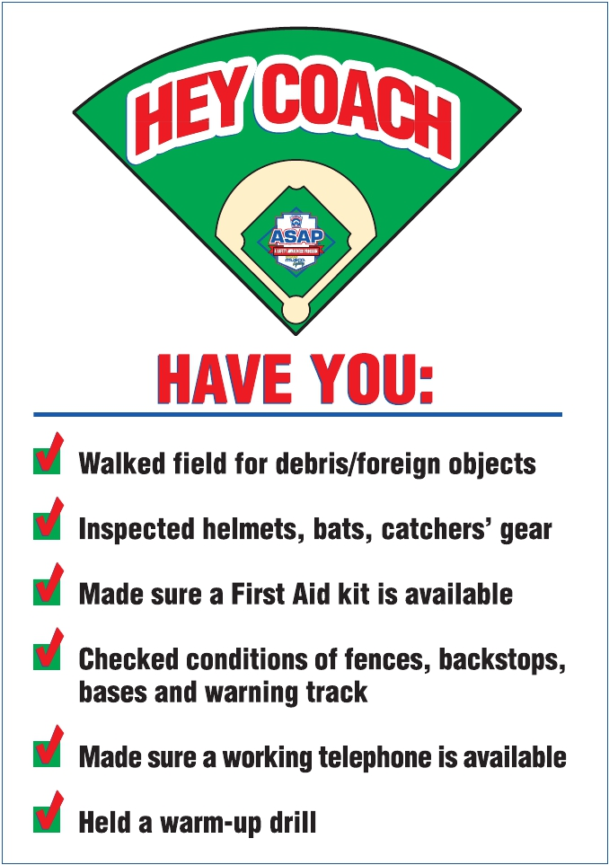

[***Code of Conduct***](http://www.littleleague.org/Assets/forms_pubs/asap/Coaches_Code_of_Conduct.pdf)

* **NO HORSEPLAY**
* **Pitcher may not blow on hand, a hand warmer in pocket is suggested. Pitcher may not lick fingers, damp cloth in plastic bag is suggested. Umpires can keep balls in a ball bag, or have a player on the bench hold them.**
* **Hand Sanitizer dispenser will be installed in all Enclosed Dugouts for player / coach use.**
* **5 MPH Speed limit on all roadways and parking lots near all little league fields.**
* **Watch For Children**
* **NO ALCOHOL!!**
* **NO SMOKING in or around fields, bleachers, or concession stands.**
* **NO SMOKING by managers or coaches during games or practices, or in the presence of any players at any Little League function.**
* **NO PROFANITY!!**
* **No throwing balls or swinging bats except on fields.**
* **No throwing rocks.**
* **No climbing fences.**
* **Players and spectators should be alert for foul balls or wild throws.**
* **Teams are responsible for cleaning up dugouts and around stands after each game or practice.**
* **NO TRASH TALK!! Players and spectators are not to argue with or ridicule any umpire, player or coach. Refer to Zero Tolerance Policy.**
* **Use of electronic devices by coaches is restricted to baseball related activity.**

***Concession Stand Guidelines***

* **Please be sure to lock the stand when you leave.**
* **Wash hands often and according to Health Department guidelines.**
* **Lock the money box at the end of the night and/or drop off to concession coordinator.**
* **Follow all rules as listed inside the concession stand regarding electrical appliances, food preparation, handling, etc.**

**Thank you for all of your helping making our concession sales safe and successful.**

***Safety Code***

* Play and Practice safe. NO HORSEPLAY!!!
* Managers and coaches must have access to a phone at all games and practices.
* No games or practices should be held when field conditions or weather are bad or lighting is inadequate.
* Play area should be inspected before every game or practice for holes, damage, stones, glass, or other hazards.
* Team equipment should be checked before every game or practice to insure that it is in good condition.
* During games and practices, all equipment is to be stored in dugouts or behind fences, NOT in play area.
* **Only players, coaches, and umpires are allowed on the field or in the dugouts during games or practices.**
* All players should be alert and watching the batter during all games and practices.
* **On deck batters are NOT permitted.**
* **A player coaching a base during a game or practice must wear a helmet.**
* **Batters MUST wear helmets during games and practices.**
* **Use of electronic devices by coaches is restricted to baseball related activity.**
* During warm ups, players should be spaced so that no one is in danger of a wild throw or missed catch.
* All warm ups, playing catch, swinging bats, etc., should be done on the playing field and not in areas where they might come in contact with spectators.
* Catchers MUST wear a helmet, mask, dangling THROAT GUARD, chest protector, shin guards, and a protective cup for all games and practices. All male players, esp. those playing infield are encouraged to wear protective cups.
* **Managers or coaches may warm up pitchers. Players MUST wear a helmet and mask with throat guard while warming up a pitcher.**
* Players may not wear jewelry, watches, rings, necklaces, etc. during games or practices.
* Parent of players who wear glasses are encouraged to supply safety glasses.
* Managers are required to have medical release forms for all players and accident report forms with them at all games and practices.
* Only authorized and trained personnel are allowed in the concession stands.

**IN CASE OF AN EMERGENCY, IMMEDIATELY CONTACT 911**

**For non-emergency needs, please contact the Traverse City Police Department at:**

**231-995-5150**

***Proper Stretching and Warm-Up Routines are Vital in Avoiding Injury***

**By: Michele Smith**

Children are naturally flexible. With young muscles still growing and developing, coaches may not think stretching is very important. Take it from two-time USA Softball Olympic Gold-Medalist Michele Smith, a proper pre- and post-workout routine can help care for the muscles that allow the players to take the field.

**Dynamic Warm-Up**  
“I encourage coaches to begin any practice or game with a dynamic warm-up,” Michele said. For younger players, 10 minutes total of blood-pumping, body-moving activity can help raise the body’s core temperature and loosen up muscles for the practice or game. Older players may need 15 minutes of warm-up. These are not static stretching exercises, but active dynamic warm-ups.

Start by having players run from foul pole to foul pole, then do some agility exercises:

* High knees
* Butt kicks
* Karaoke run
* Jumping jacks
* Arm windmills
* Neck circles

“The goal is to work on all the body parts: trunk, arms, legs and neck,” Michele said. “Muscles stretch more easily if the body is warmed up properly before you stretch.”

If muscles are still tight after the dynamic warm-up, then do some specific stretching for the area. Pitchers especially, but all players need to really work on their shoulder muscles, to make sure they are loose before throwing. And coaches should be reminded to have their players do stretching and warm-up exercises any time they have been idle for a period.

Planning can help reduce the amount of stretching needed. Some coaches have players warm up their arms, do a few defensive drills, stand around waiting to hit and then start back throwing. Instead, start players hitting, then go to throwing drills, making sure they stretch out their arms before throwing. It saves time stretching and saves injuries to arms. Be sure to warm up and stretch the trunk before hitting, or players risk injuries like groin pulls.

**Then Cool Down**  
After a practice or game, don’t just send your kids home. Muscles need to be worked to get new oxygen in and remove the waste by-products of exercising. “Have players run a lap around the field, then sit in a circle and stretch muscles to get fresh blood in them, and help strengthen them,” Michele said.

She suggests arm windmills, neck circles and hurdler’s stretches for the quads and glutes (thighs and bottom). Twisting exercises that stretch the side muscles and back also are good. As an example, sit on the ground, placing the foot of a bent leg on the opposite side of an outstretched leg’s knee, and twist your torso across the upright knee. Then switch legs and twist the other way.

“A good cool down will help cool the muscles and slow the heart rate,” Michele said. “It’s important not to over-stretch in the cool down phase,” she noted, since the muscles are being relaxed. If any sore spots are found during stretching, apply ice.

Michele said warm ups are a good time for players to visualize what they will be doing: hitting, pitching, throwing out base runners, etc. Cool downs are a time to reflect on the practice on what went well, and what may need improvement. But above all, these tips can keep players playing, and not sidelined with muscle injuries.

“If you’re injured, you can’t play the sport you love,” Michele said. “We need to warm up and cool down to prevent injuries. Young kids are so flexible, they don’t realize they can pull muscles. So for younger players, this is as much about instilling good routines for the players for later in life

***Communicable Disease Procedures***

* Bleeding must be stopped, the open wound covered, and the uniform changed if there is blood on it before the athlete may continue.
* Always use gloves when contact with blood or other body fluids are anticipated.
* Immediately wash your hands and other skin surfaces if contaminated with blood.
* Clean all bloody surfaces and equipment properly.
* Managers, coaches, and volunteers with open wounds should refrain from all direct contact until the condition is resolved.
* Follow accepted guidelines in the immediate control of bleeding and disposal when handling bloody dressings, mouth guards, and other articles containing body fluids.

When treating an injury, remember:

Protection

Rest

Ice

Compression

Elevation

Support

***Summer is coming, be aware of the heat!!***

MC900389354[1]

Heat stroke and heat exhaustion are very dangerous conditions that occur when the body loses too much fluid due to perspiration. Some of the signs of heat exhaustion or heat cramps are:

* Dizziness
* Tingling
* Chills
* Cramps
* Mental Confusion

Heat stroke is a life threatening condition and needs immediate medical care. Some signs are;

* Red flush skin
* Loss of consciousness
* Inability to sweat

**TIPS FOR AVOIDING HEAT RELATED INJURIES:**

* + Be sure to have plenty of water available at all practices and games.
  + Give players plenty of breaks for rest and drinks.
  + Closely watch all players, especially catchers and pitchers.
  + If you think they may be getting over heated, THEY ARE!!

*Remember, Safety is everyone’s job!*

*Report all hazardous conditions to the safety officer immediately!*

*Never play in unsafe weather or without proper equipment!*

***Safety Do’s and Dont’s***

Do…

* HAVE SAFETY AS YOUR TOP PRIORITY FOR YOUR PLAYERS.
* Help children who are injured, frightened or lost.
* Get medical attention for those who need it…. CALL 911.
* Know your limitations.
* Carry a first-aid kit to all games and practices.
* Have your players’ medical release forms with you at all games and practices.
* Assure injured players have a written physician approval to return after serious injuries. Concussions require written physician and parent approval for player to resume play or practice.
* Have a cell phone available at all games and practices.
* LOOK for signs of injury.
* Listen to the injured player describe what happened and what hurts.

Don’t…

* Administer any medications.
* Straighten any deformed arm or leg injuries.
* Hesitate to ask for help.
* Ask players to play hurt.
* Be afraid to ask for help when you are not sure what to do.
* Transport injured individuals except in extreme circumstances.
* Leave child unattended at game or practices.
* Hesitate to report any present or potential safety hazard to the safety officer.

What To Report - Any incident that causes any player, coach, umpire, or volunteer to receive medical treatment MUST be reported to the Safety Officer.

When To Report – Any incident described above MUST be reported to the Safety Officer within 48 hours. The Safety Officer(s) for the 2022 season is:

Kyle Kendzicky

Email: kyle.kendzicky@gmail.com

How To Report – The initial report may be by phone, but the attached incident report should be filled out as completely as possible and turned in to the Safety Officer within 48 hours of the incident.

**IN CASE OF AN EMERGENCY, IMMEDIATELY CONTACT 911**

**For non-emergent needs, please contact the Traverse City Police Department at:**

**231-995-5150**



***Signs and Symptoms of Concussion***

  There are many different symptoms reported by athletes who suffer concussions, and in some cases they may not be easily detected for hours or days after the injury. Look for clues immediately and make sure athletes are re-evaluated every few minutes over several hours.  At home, parents should watch for the following symptoms as well as complaints that lights are too bright, noises too loud, or your child has difficulty concentrating while watching TV or playing video games.  Any of the following are indicative of concussion, according to the CDC:

<http://www.cdc.gov/concussion/HeadsUp/pdf/Baseball_Clipboard_Sticker.pdf>

|  |  |
| --- | --- |
| * Appears dazed or stunned * Is confused about assignment or position * Forgets an instruction * Is unsure of game, score, or opponent * Moves clumsily * Answers questions slowly * Loses consciousness (even briefly) * Shows mood, behavior, or personality changes * Can’t recall events prior to hit or fall * Can’t recall events after hit or fall | * Headache or “pressure” in head * Nausea or vomiting * Balance problems or dizziness * Double or blurry vision * Sensitivity to light * Sensitivity to noise * Feeling sluggish, hazy, foggy, or groggy * Concentration or memory problems * Confusion * Does not “feel right” or is “feeling down” |
|  |  |

[Concussion Experts: For Kids- No Sports, No Schoolwork, No Text Messages](http://www.childrensnational.org/pressroom/NewsReleases/ConcussionGuidelinesJune09.aspx)     
  
Some signs and symptoms are subtle.  Encourage athletes to report any of the above, and do not allow them to participate in a game or practice until a qualified medical professional has given the OK and they are 100% symptom-free both at rest and during a [gradual return-to-play procedure](http://www.sportsconcussions.org/return-to-play.html).

**Safety Procedures**

***A. Safe Playing Areas***

Regular safety inspections of all fields, (practice and game), structures, and dugouts, is the best way to eliminate conditions that cause accidents.

Managers, coaches, and umpires should routinely check playing area for:

1. Holes, damage, rough or uneven spots, slippery areas, and long grass.

2. Glass, rocks, foreign objects.

3. Damage to screens or fences, including holes, sharp edges, or loose edges.

4. Unsafe conditions around backstop, pitcher’s mound, or warning track.

5. Proper attire by the catcher at all times, including in the bull pens and in between innings.

***B. Safe Equipment***

All equipment shall be inspected before each use. Regular safety inspection of equipment is essential. Managers, coaches, and umpires should:

1.Be sure all equipment is LL approved.

2. Inspect all bats, helmets, and other equipment on a regular basis. Dispose of unsafe equipment properly.

3.Keep loose equipment stored properly

4.Have all players remove all personal jewelry.

5.Parents should be encouraged to provide safety glasses for players who wear glasses.

6. Repair or replace defective equipment.

***C. Safe Procedures***

Managers and coaches must:

1. Have all players’ medical release forms with you at every practice and game.

2. Have a first aid kit with you all practices and games.

3. Have access to a telephone in case of emergencies.

4. Know where the closest emergency shelter is in case of severe weather.

5. Ensure warm-up procedures have

been completed by all players.

6. Stress the importance of paying attention, no “horse playing allowed”.

7. Instruct the players on proper fundamentals of the game to ensure safe participation.

8. Each practice should have at least 2 coaches in case of an emergency.

***D. Weather Conditions***

Before the Storm

1. Check the weather forecast before leaving for a game or practice.

2. Watch for signs of an approaching storm.

3. Postpone outdoor activities if storms are imminent.

***Approaching Thunderstorm***

1. Take caution when you hear thunder. If you hear thunder, you are close enough to get struck by lightning.

During a game, the umpire will clear the field in the event of an approaching storm.

2. Move to a safe environment immediately. Do not go under a tree or stay in the dugout.

3. If lightening is occurring and there is not sturdy shelter near, get inside a hard top automobile and keep the window up.

4. Stay away from water, metal pipes, and telephone lines.

5. Unplug appliances not necessary for obtaining weather information. Avoid the telephone except for emergency use only.

6. Turn off air conditioners.

***If caught outdoors & no shelter exists***

1. Find a low spot away from trees, fences, light poles, and flagpoles. Make sure the site you pick is not prone to flooding.

2. If in the woods, take cover under shorter trees.

3. If you feel your skin begin to tingle or your hair feels like it’s standing on end, squat low to the ground, balancing on the balls of your feet.

Make yourself the smallest possible target, tuck your head between your legs, and minimize your contact with the ground.

***What to do if someone is struck***

***by lightning***

1. The person who has been struck will carry no electrical charge; therefore, they are safe to touch.

2. Call 9-1-1 as soon as possible for help.

3. Check for burns to the body.

4. Give first aid as needed.

5. If breathing and/or heartbeat have stopped, perform CPR until EMS arrives.

6. Contact the league Safety Officer or President ASAP.

***Lightning Safety Guidelines***

Each year across the United States, thunderstorms produce an estimated 25 million cloud-to-ground flashes of lightning - each one of those flashes is a potential killer.  According to the National Weather Service, an average of 73 people are killed by lightning each year and hundreds more are injured, some suffering devastating neurological injuries that persist for the rest of their lives.  A growing percentage of those struck are involved in outside recreational activities.

Officials responsible for sports events often lack adequate knowledge of thunderstorms and lightning to make educated decisions on when to seek safety.  Without knowledge, officials base their decisions on personal experience and, sometimes, on the desire to complete the activity.  Due to the nature of lightning, personal experience can be misleading.

While many people routinely put their lives in jeopardy when thunderstorms are nearby, few are actually struck by lightning.  This results in a false sense of safety.  Unfortunately, this false sense of safety has resulted in numerous lightning deaths and injuries during the past several decades because people made decisions that unknowingly put their lives or the lives of others at risk.

For organized outdoor activities, the National Weather Service recommends those in charge have a lightning safety plan, and that they follow the plan without exception.  The plan should give clear and specific safety guidelines in order to eliminate errors in judgment.  Prior to an activity or event, organizers should listen to the latest forecast to determine the likelihood of thunderstorms.  NOAA Weather Radio is a good source of up-to-date weather information.  Once people start to arrive, the guidelines in your league's lightning safety plan should be followed.

A thunderstorm is approaching or nearby.  Are conditions safe, or is it time to head for safety?  Not wanting to appear overly cautious, many people wait far too long before reacting to this potentially deadly weather threat.   The safety recommendations outlined here are based on lightning research and the lessons learned from the unfortunate experiences of thousands of lightning strike victims.

Thunderstorms produce two types of lightning flashes, 'negative' and 'positive.'   While both types are deadly, the characteristics of the two are quite different.  Negative flashes occur more frequently, usually under or near the base of the thunderstorm where rain is falling.  In contrast, positive flashes generally occur away from the center of the storm, often in areas where rain is not falling.   There is no place outside that is safe in or near a thunderstorm.  Consequently, people need to stop what they are doing and get to a safe place immediately.  Small outdoor buildings including dugouts, rain shelters, sheds, etc., are NOT SAFE.  Substantial buildings with wiring and plumbing provide the greatest amount of protection.  Office buildings, schools, and homes are examples of buildings that would offer protection.  Once inside, stay away from windows and doors and anything that conducts electricity such as corded phones, wiring, plumbing, and anything connected to these.   In the absence of a substantial building, a hard-topped metal vehicle with the windows closed provides good protection.  Occupants should avoid contact with metal in the vehicle and, to the extent possible, move away from windows.

**Who should monitor the weather and who is responsible for making the decision to stop activities?**

Lighting safety plans should specify that someone be designated to monitor the weather for lightning.  The 'lightning monitor' should not include the coaches, umpires, or referees, as they are not able to devote the attention needed to adequately monitor conditions.  The 'lightning monitor' must know the plan's guidelines and be empowered to assure that those guidelines are followed.

**When should activities be stopped?**

The sooner activities are stopped and people get to a safe place, the greater the level of safety.  In general, a significant lightning threat extends outward from the base of a thunderstorm cloud about 6 to 10 miles.  Therefore, people should move to a safe place when a thunderstorm is 6 to 10 miles away.  Also, the plan's guidelines should account for the time it will take for everyone to get to a safe place.  Here are some criteria that could be used to halt activities.

1. **If lightning is observed.**  The ability to see lightning varies depending on the time of day, weather conditions, and obstructions such as trees, mountains, etc.  In clear air, and especially at night, lightning can be seen from storms more than 10 miles away provided that obstructions don't limit the view of the thunderstorm.
2. **If thunder is heard.**  Thunder can usually be heard from a distance of about 10 miles provided that there is no background noise.  Traffic, wind, and precipitation may limit the ability to hear thunder less than 10 miles away.  If you hear thunder, though, it's a safe bet that the storm is within 10 miles.
3. **If the time between lightning and corresponding thunder is 30 seconds or less.**  This would indicate that the thunderstorm is 6 miles away or less.  As with the previous two criteria, obstructions, weather, noise and other factors may limit the ability to use this criterion.  In addition, a designated person must diligently monitor any lightning.  In addition to any of the above criteria, activities should be halted if the sky looks threatening.  Thunderstorms can develop directly overhead and some storms may develop lightning just as they move into an area.

**When should activities be resumed?** Because electrical charges can linger in clouds after a thunderstorm has passed, experts agree that people should wait **at least 30 minutes after the storm before resuming activities**.

**What should be done if someone is struck by lightning?**

Most lightning strike victims can survive a lightning strike; however, medical attention may be needed immediately - have someone call for medical help.  Victims do not carry an electrical charge and should be attended to at once.  In many cases, the victim's heart and/or breathing may have stopped and CPR may be needed to revive them.  The victim should continue to be monitored until medical help arrives; heart and/or respiratory problems could persist, or the victim could go into shock.  If possible, move the victim to a safer place away from the threat of another lightning strike.

**This article is printed in the back of the Little League Rule Book - Appendix**

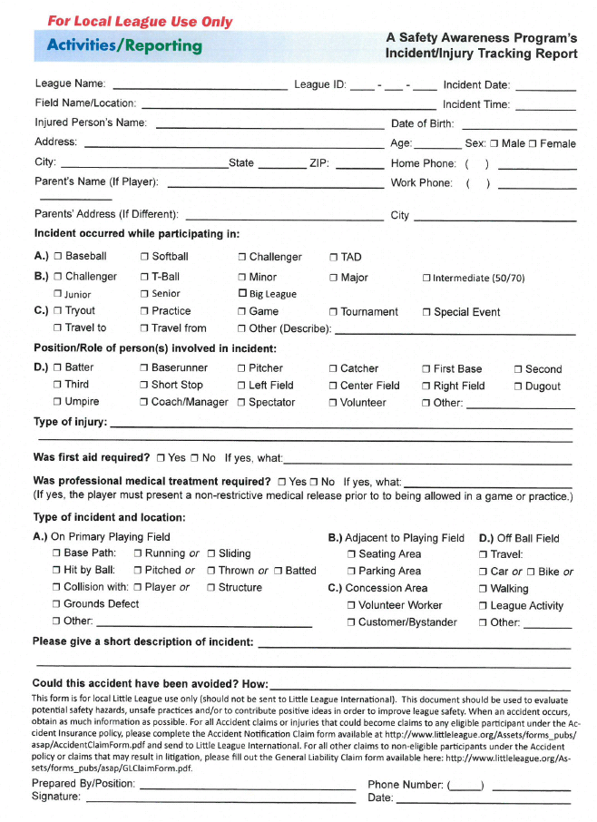

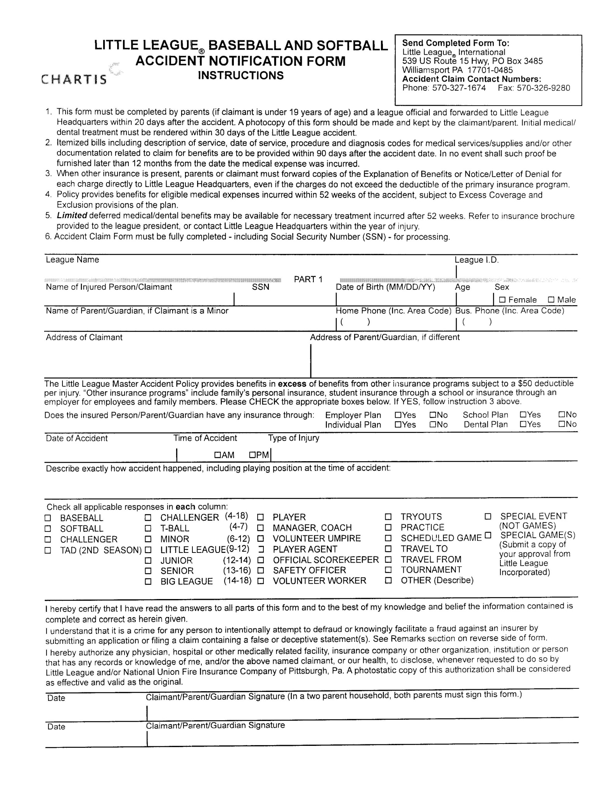

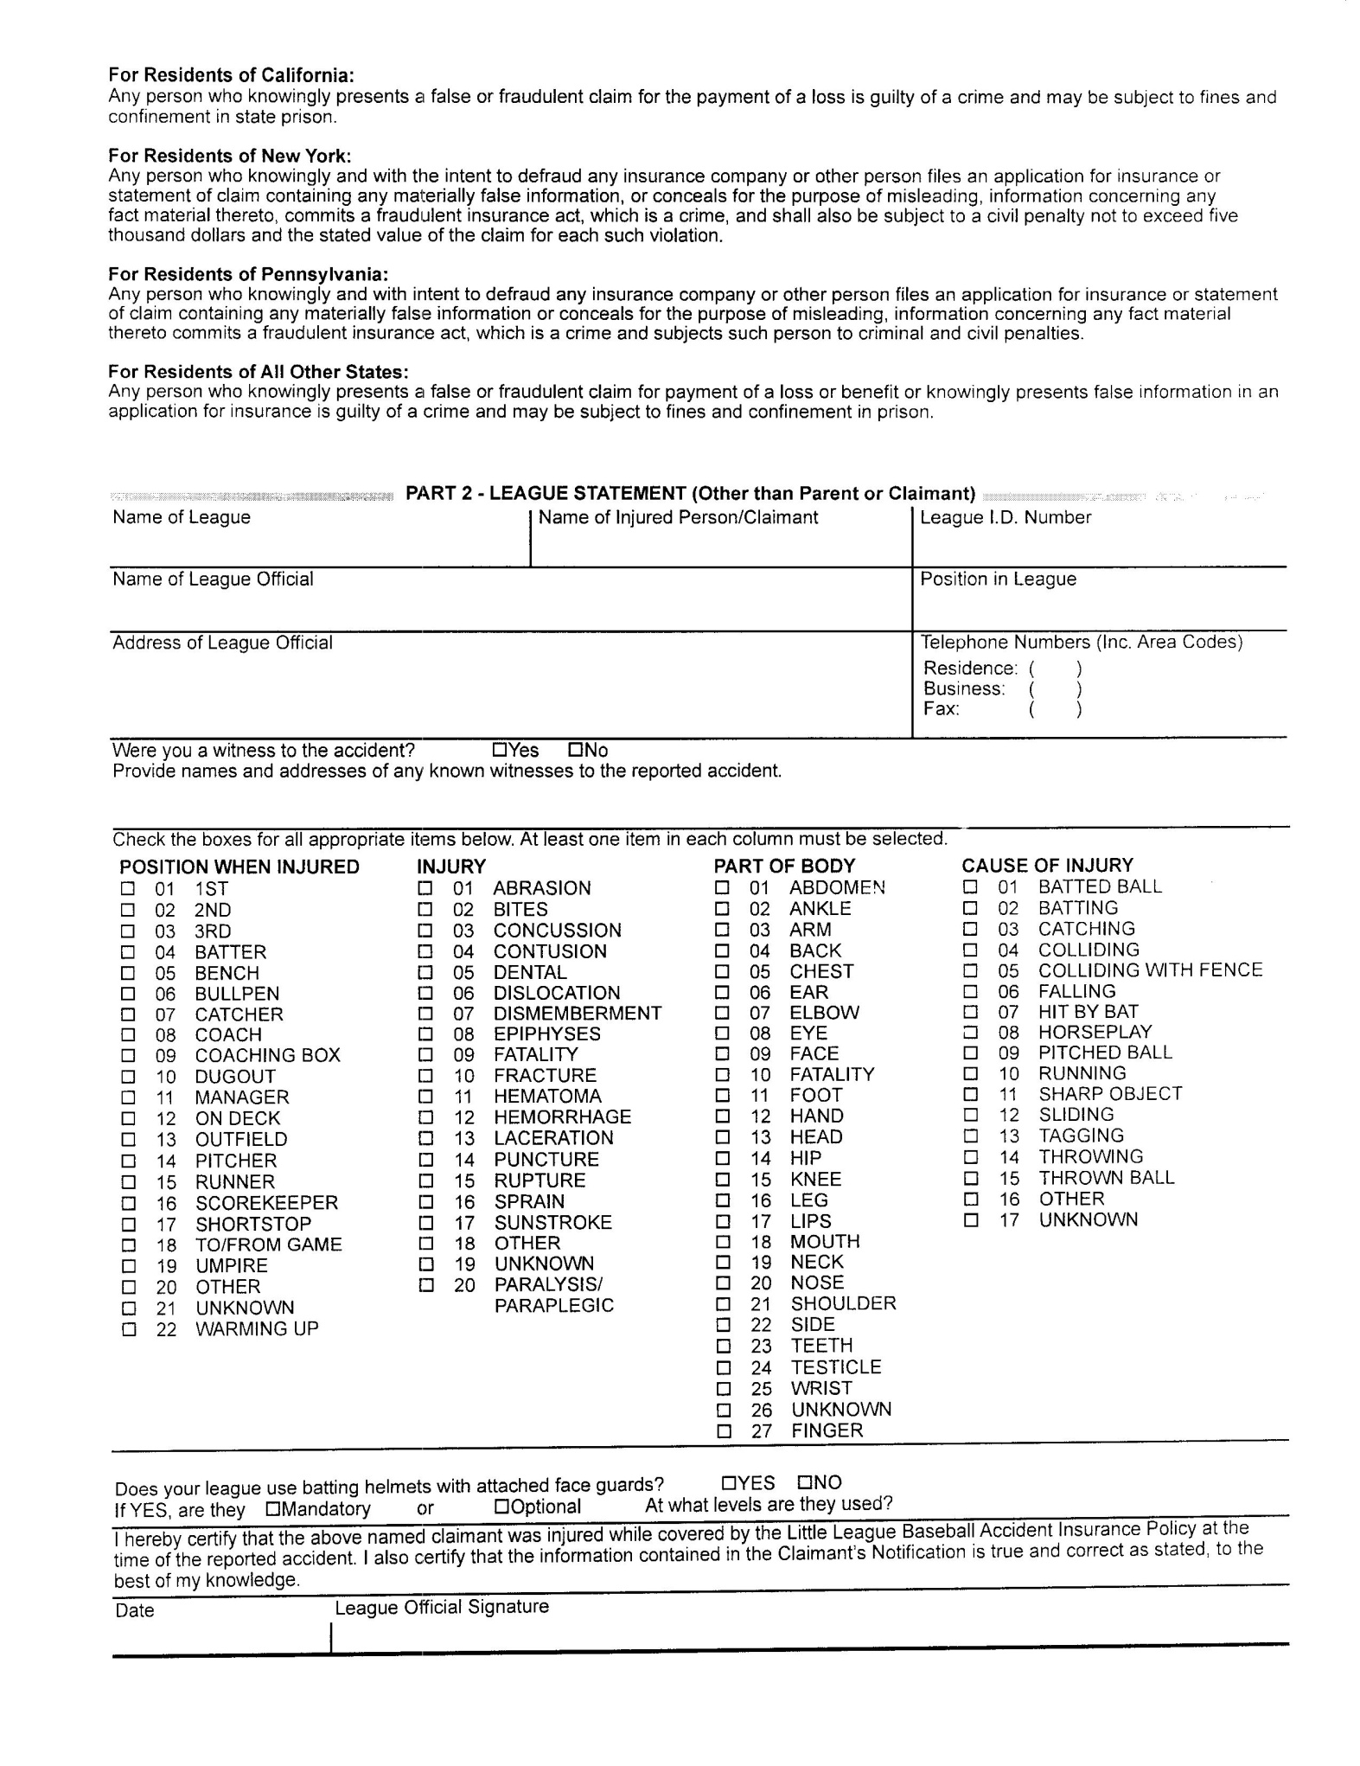

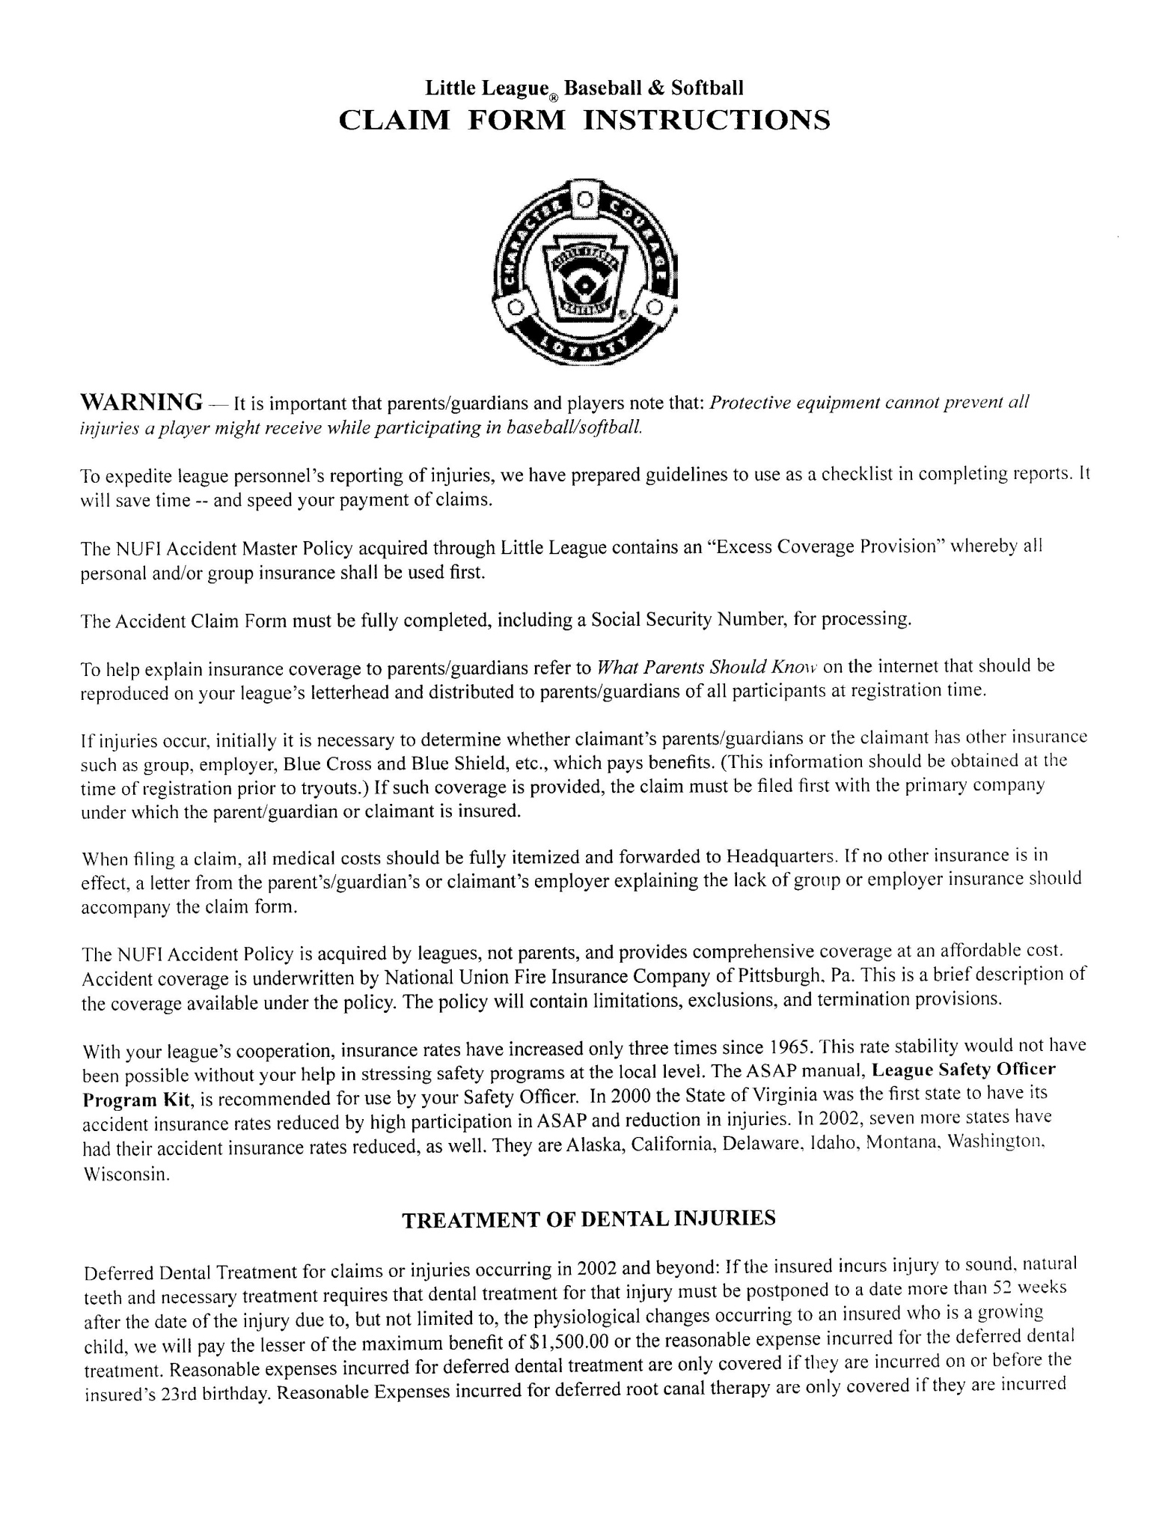

**Little League Volunteer Application – 2023**

**Do not use forms from past years. Use extra paper to complete if additional space is required.**

**A COPY OF VALID GOVERNMENT ISSUED PHOTO IDENTIFICATION MUST BE ATTACHED TO COMPLETE THIS APPLICATION.** Name __________________________________ Date ___________________ Address ________________________________________________________ City ____________________________ State _________Zip _____________ **Social Security # (mandatory with First Advantage )** _______________ Cell Phone Business Phone Home Phone: _____________ E-mail Address: Date of Birth ____________________________________________________ Occupation _____________________________________________________ Employer _______________________________________________________ Address ________________________________________________________ Special professional training, skills, hobbies: ___________________________ _______________________________________________________________ Community affiliations (Clubs, Service Organizations, etc.): _______________________________________________________________ Previous volunteer experience (including baseball/softball and year): _______________________________________________________________Do you have children in the program? Yes No If yes, list full name and what level? _____________________________________________________ Special Certification (CPR, Medical, etc.): ______________________________Do you have a valid driver’s license: Yes No Driver’s License#: ________________________________State ___________Have you ever been convicted of or plead guilty to any crime(s) involving or against a minor?: Yes No If yes, describe each in full: _________________________________________ _______________________________________________________________Are there any criminal charges pending against you regarding any crime(s) involving or against a minor? Yes No If yes, describe each in full:______________ __________________________________________________________________Have you ever been refused participation in any other youth programs? Yes No If yes, explain: ___________________________________________________ _______________________________________________________________In which of the following would you like to participate? (Check one or more.)

League Official Coach Umpire Field Maintenance

Manager Scorekeeper Concession Stand Other

Please list three references, at least one of which has knowledge of your participation as a volunteer in a youth program:

**Name/Phone**

______________________________________________________________________

______________________________________________________________________

______________________________________________________________________

IF YOU LIVE IN A STATE THAT REQUIRES A SEPARATE BACKGROUND CHECK BY LAW, PLEASE ATTACH A COPY OF THAT STATE’S BACKGROUND CHECK. FOR MORE INFORMATION ON STATE LAWS, VISIT OUR WEBSITE:

http://www.littleleague.org/learn/programs/childprotection/state-laws-bg-checks.htm

AS A CONDITION OF VOLUNTEERING, I give permission for the Little League organization to conduct background check(s) on me now and as long as I continue to be active with the organization, which may include a review of sex offender registries (some of which contain name only searches which may result in a report being generated that may or may not be me), child abuse and criminal history records. I understand that, if appointed, my position is conditional upon the league receiving no inappropriate information on my background. I hereby release and agree to hold harmless from liability the local Little League, Little League Baseball, Incorporated, the officers, employees and volunteers thereof, or any other person or organization that may provide such information. I also understand that, regardless of previous appointments, Little League is not obligated to appoint me to a volunteer position. If appointed, I understand that, prior to the expiration of my term, I am subject to suspension by the President and removal by the Board of Directors for violation of Little League policies or principles.

Applicant Signature________________________________________Date__________

If Minor/Parent Signature___________________________________Date __________

Applicant Name(please print or type)________________________________________

*NOTE: The local Little League and Little League Baseball, Incorporated will not discriminate against any person on the basis of race, creed, color, national origin, marital status, gender, sexual orientation or disability.*

**LOCAL LEAGUE USE ONLY:**

Background check completed by league officer ________________________________ on ____________________________________________________________________System)s) used for background check (minimum of one must be checked):Regulation I(c)(9) Mandates First Advantage or another provider that is comparable

*First Advantage Sex Offender Registry Data along with a National Criminal Records check of at least 281 million records

*Please be advised that if you use First Advantage and there is a name match in the few states where only name match searches can be performed you should notify volunteers that they will receive a letter directly from LexisNexis in compliance with the Fair Credit Reporting Act containing information regarding all the criminal records associated with the name, which may not necessarily be the league volunteer. **Only attach to this application copies of background check reports that reveal convictions of this application.**